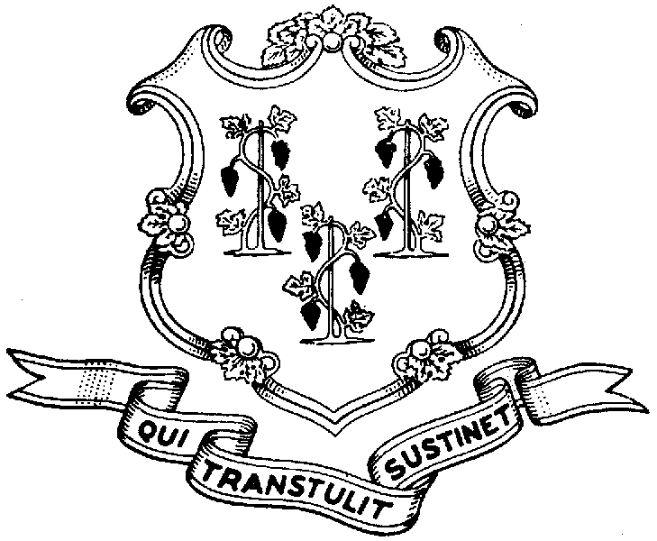



***Behavioral Health Partnership Oversight Council***

Legislative Office Building Room 3000, Hartford CT 06106

(860) 240-0346 Info Line (860) 240-8329 FAX (860) 240-5306

**www.cga.ct.gov/ph/BHPOC**

*Co-Chairs: Rep. Mike Demicco, Sharon Langer & Hal Gibber*

November 23, 2015

Governor Dannel P. Malloy

State Capitol

210 Capitol Avenue

Hartford, CT 06106

Re: Proposed Reductions to Behavioral Health Services for Children and Adults

Dear Governor Malloy,

We are writing on behalf of the Connecticut Behavioral Health Partnership Oversight Council to express our deep distress about the latest proposed reductions to the state budget and their anticipated impact on access to mental health and substance abuse services for adults with mental illness and substance abuse disorders, the hundreds of thousands of children and families on HUSKY health coverage, as well as the many other families who need access to timely and quality behavioral health services.

The Behavioral Health Partnership Oversight Council includes families and adults directly affected by mental illness and substance abuse, as well as organizations that represent their interests, child guidance clinics, behavioral health clinics, large healthcare systems, school based health centers, home health care providers, and regional mental health boards. The statutorily created Council is tasked with advising the Behavioral Health Partnership agencies - the Departments of Social Services, Mental Health and Addiction Services, and Children and Families – in their mission to improve access and coordination of services to vulnerable children, families, low-income adults, individuals with severe disabilities, and the fragile elderly.

We wrote earlier this year to Secretary Barnes to express similar concerns about proposals to disinvest in effective mental health and substance abuse prevention and treatment services for children and adults. Such funding cuts will have a deleterious impact on families, children, and communities of Connecticut. They will result in reduction in service, some providers closing their doors, increased delays in accessing community-based outpatient services which in turn will lead to more individuals showing up at emergency departments, or being admitted to hospitals where the price tags are highest. In a time when our communities want and believe that resources for the care of people of all ages with mental illness and substance use disorders are increasing, the proposed budget reduces access to such services.

Here are several examples of how the cuts will hurt children and families:

1. Although you have committed to support increased funding in the budget to expand the capacity of **Emergency Mobile Psychiatric Services (EMPS)**, (an initiative created as the result of the Sandy Hook tragedy) that delivers critical services for children and adolescents statewide, the contract amendment to expand such services is now being delayed due to the ongoing budget negotiations. EMPS saves lives while saving the state money by diverting children from emergency departments and hospitalizations. Current funding has not kept up with the increase in call volume and EMPS providers are unable to respond to the additional calls for help without additional dollars. We fear that this delay will turn into a lapse of funding and the promised expanded hours and operation of EMPS will not be implemented, leaving families in crisis without this vital service.
2. The Regional Behavioral Health Consultation to Healthcare Providers, known as “**ACCESS-Mental Health”** also became law in the wake of Newtown. ACCESS-Mental Health has been hailed as a successful early intervention model that improves access to timely care to children. The initiative enables pediatricians to obtain psychiatric consultation services and help with coordinating services for children and their families. According to information provided at this week’s Council meeting, over 1,500 children and their families were served by this program in its first full year in operation. It should not be eliminated.
3. Once again there are proposes cuts to the **grant accounts in the DMHAS budget**, affecting thousands of adults seeking outpatient care for mental illness and substance use disorders.  These cuts are on top of the cuts made when the state budget was adopted in June and the ones made as a result of rescissions in September.  These continued cuts will cause reduced access to services.
4. In the 2013 Value Options report on Emergency Department Utilization report, 57% of adults who utilized the emergency department for a behavioral service had a co-occurring diagnosis of substance use disorder. The closing of the **20 Acute Detox beds at Connecticut Valley Hospital** would place an undue strain on Emergency Departments across the state that already struggle to arrange for treatment for patients with substance abuse disorders who have acute medical co-morbidities. Merritt Hall provides a 4.2 level of care that allows them to manage medical conditions such as liver failure, uncontrolled diabetes and renal failure. Without this level of care hospitals would not have access to appropriate aftercare options.
5. **School-Based Health Centers** (SBHCs) provide early intervention medical and mental health services to 40,000 children across the state. The Sandy Hook Commission report recommended support and expansion of SBHCs. The proposed budget would again reduce funding for the Centers (a reduction of hundreds of thousands of dollars on top of reductions of 10.5 percent in the last budget cycle through cuts and rescissions). This is at the same time that children’s visits for mental health services at SBHCs have risen 11% during the last four years. These reductions will lead to fewer children receiving early intervention and cost-effective services provided by SBHCs, services that keep them in school and achieving their fullest potential.

The findings and recommendations of several bodies, including the *Children’s Behavioral Health Task Force* and the *Sandy Hook Commission*, call for further investments in a coordinated behavioral health system. This is no time for disinvestment in behavioral health services that help hundreds of thousands of our most vulnerable residents.

We continue to be mindful of the challenges your administration and the General Assembly face in producing a balanced budget but in our role as an advisory council we must speak out about the real harm that these budget choices will cause.

We stand ready to assist you and the General Assembly in developing a budget that maintains and strengthens the Behavioral Health Partnership, as well as the behavioral health system as a whole, and protects children and adults from experiencing downward spirals, with the resultant harm to their families and communities, and more costly care due to budget cutbacks.

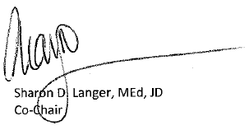Very truly yours,

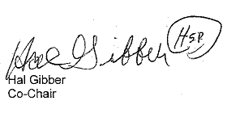



CC: Behavioral Health Partnership Oversight Council

Commissioner Roderick Bremby, DSS

Commissioner Miriam Delphin-Rittmon, DMHAS

Commissioner Joette Katz, DCF

Benjamin Barnes, Secretary, OPM

Anne Foley, Undersecretary, OPM

William Halsey, DSS

Colleen Harrington, DMHAS

Karen Andersson, DCF

Senator Martin Looney

Senator Leonard Fasano

Representative Brendan Sharkey

Representative Themis Klarides